NAME: AKSHAT KUMAR MISHRA

Class: DevOps, Batch 2021

Sap ID: 500076758

Subject: Data Communications and Computer Networks Lab.

Experiment – 4

Cisco Packet Tracer

Aim: Set –up the network topology using two routers on Packet tracer

Output: Step 1



Step 2:

Setup the network

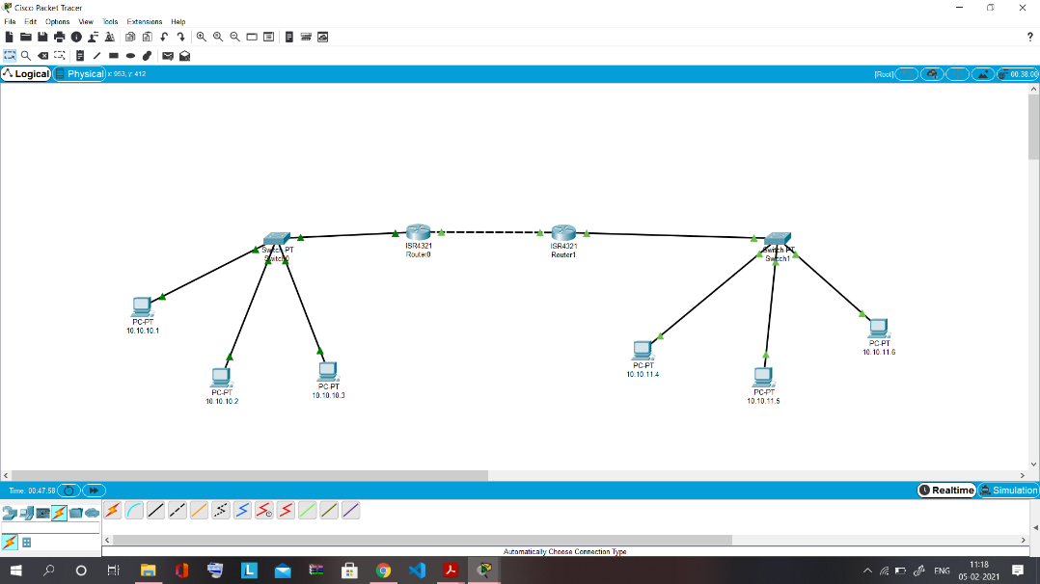

Step 3: Assign the IP Addresses to end devices

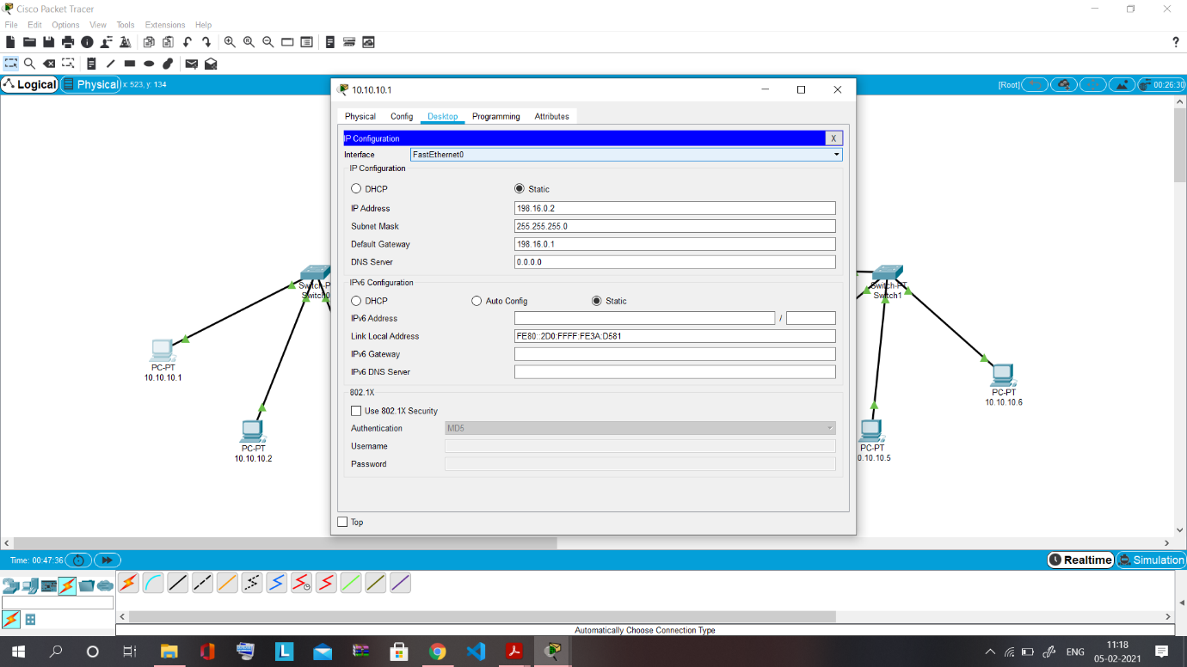

Step 4: Assign the IP Addresses to the routers

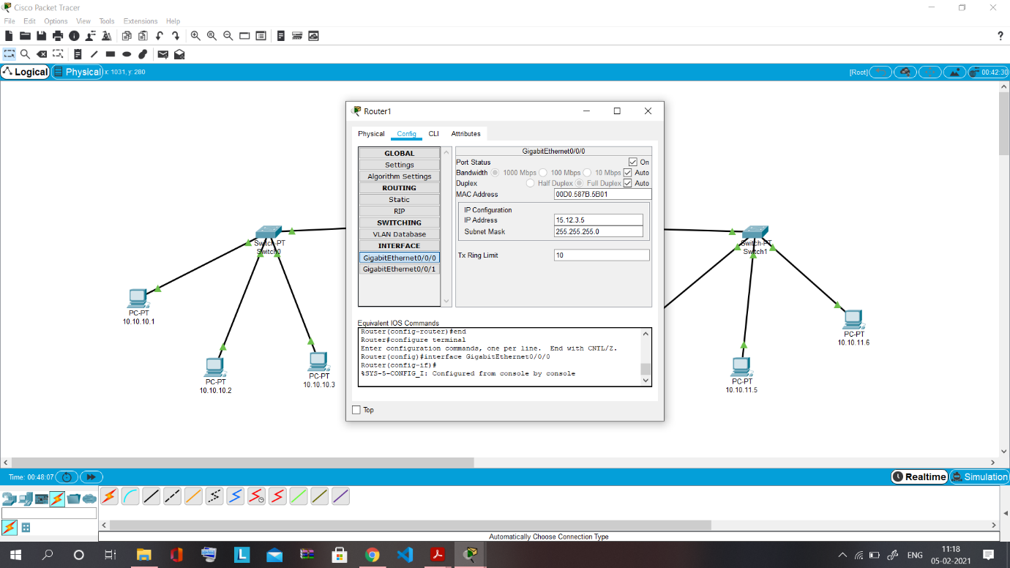

Configure the routers..

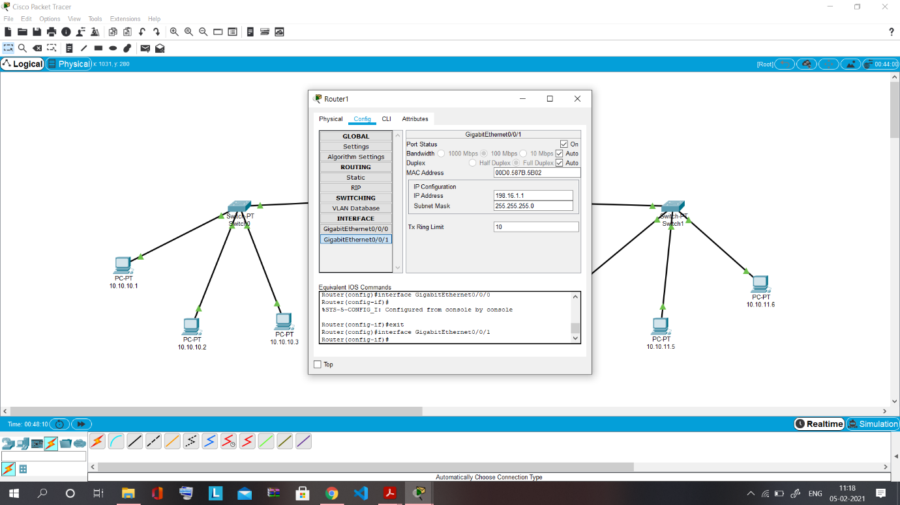

Step 5: Communicate b/w 2 end devices in the network

